Assignment 3: Dashboard

Name: Megh Dave

**Submission:**

**Please submit your finished “Assignment 3 Q1.twbx” and “Assignment 3 Q2.twbx” to the blackboard, no word documents or screenshots are needed in this submission.**

1. Advanced Filter

**Please use “Assignment 3 Q1.twbx” to complete the following tasks.** The worksheets “Coffee Profits by State and Product” and “Coffee Profits and Marketing” are built using Coffee Chain data source. The worksheets “SuperStore Profit Cross Table”, “SuperStore Profit Map”, “SuperStore Profit Scatter Plot”, “SuperStore Profits by Region and Segment” and “SuperStore Profits and Sales” are based on SuperStore data source.

a. Generate a dashboard (Dashboard 1) with worksheets “Coffee Profits by State and Product”, “Coffee Profits and Marketing”, “SuperStore Profits by Region and Segment”, “SuperStore Profits and Sales”;

b. Generate a Region Selection filter with Central, East, South and West, and use this Region Selection to filter all the worksheets in Dashboard 1;

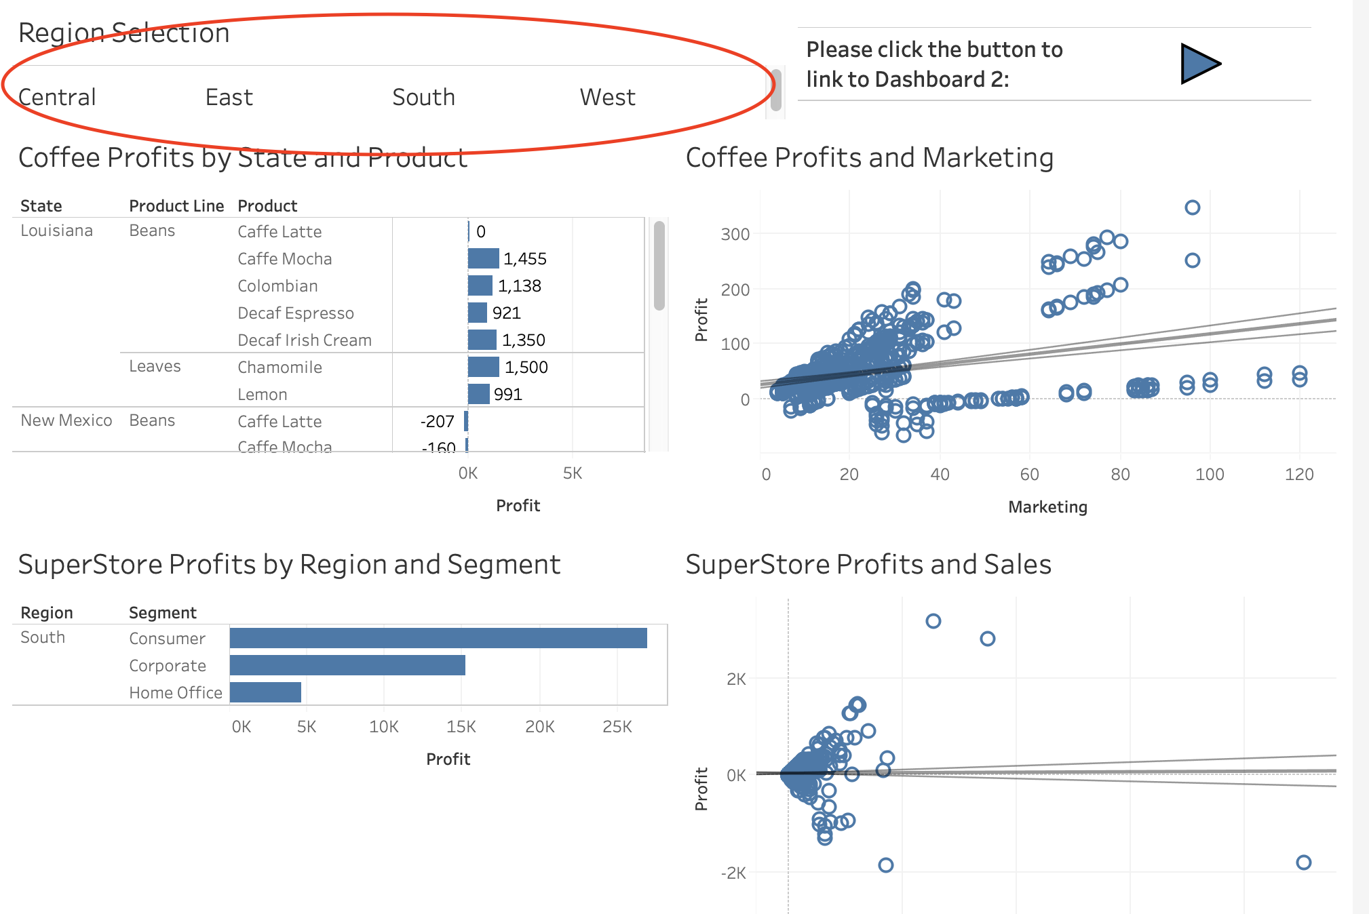

c. Generate a dashboard (Dashboard 2) with worksheets “SuperStore Profit Cross Table”, “SuperStore Profit Map”, and “SuperStore Profit Scatter Plot”;

d. Use the states from “SuperStore Profit Map” to filter the scatters from “SuperStore Profit Scatter Plot”; and use the scatters from “SuperStore Profit Scatter Plot” to filter the content from “SuperStore Profit Cross Table”. Hide the worksheets “SuperStore Profit Cross Table” and “SuperStore Profit Scatter Plot” before making a selection on the map;

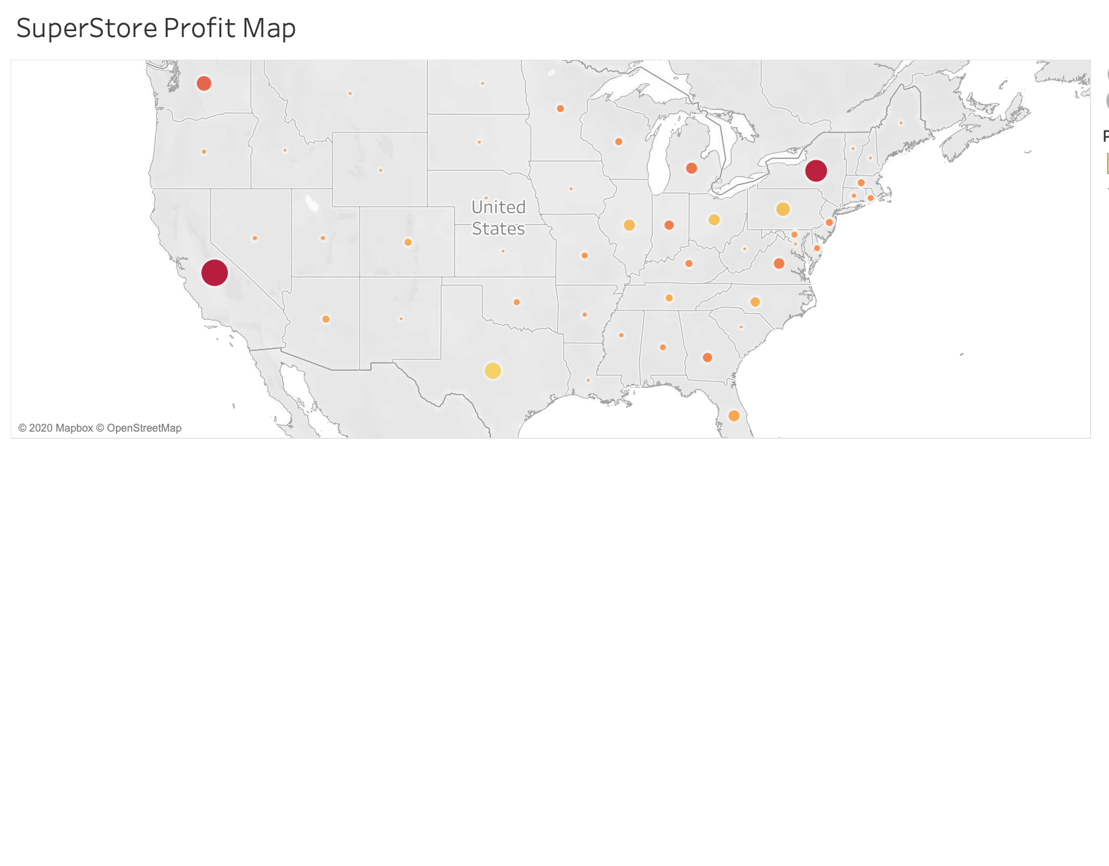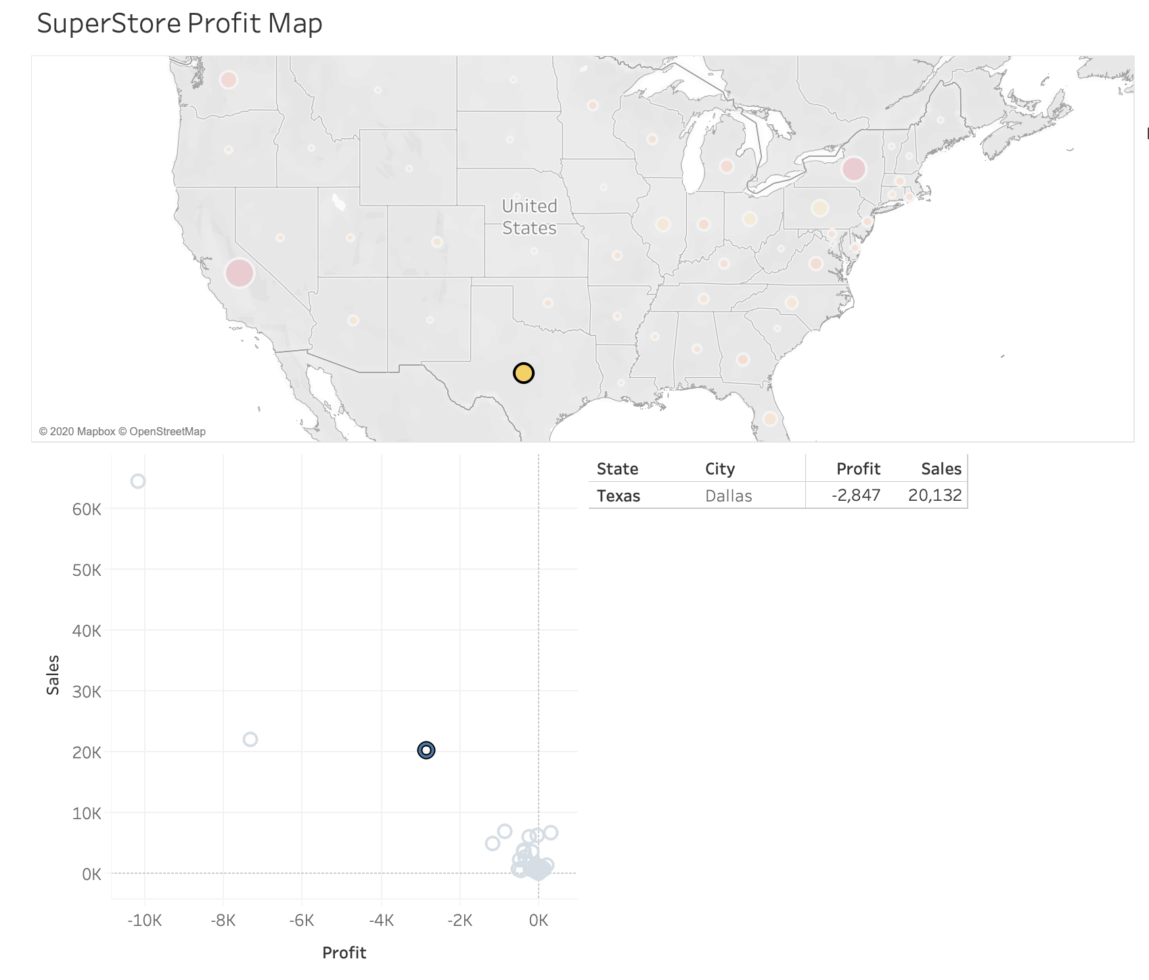

e. Generate two worksheets navigating from Dashboard 1 to Dashboard 2, and directing from Dashboard 2 to Dashboard 1;

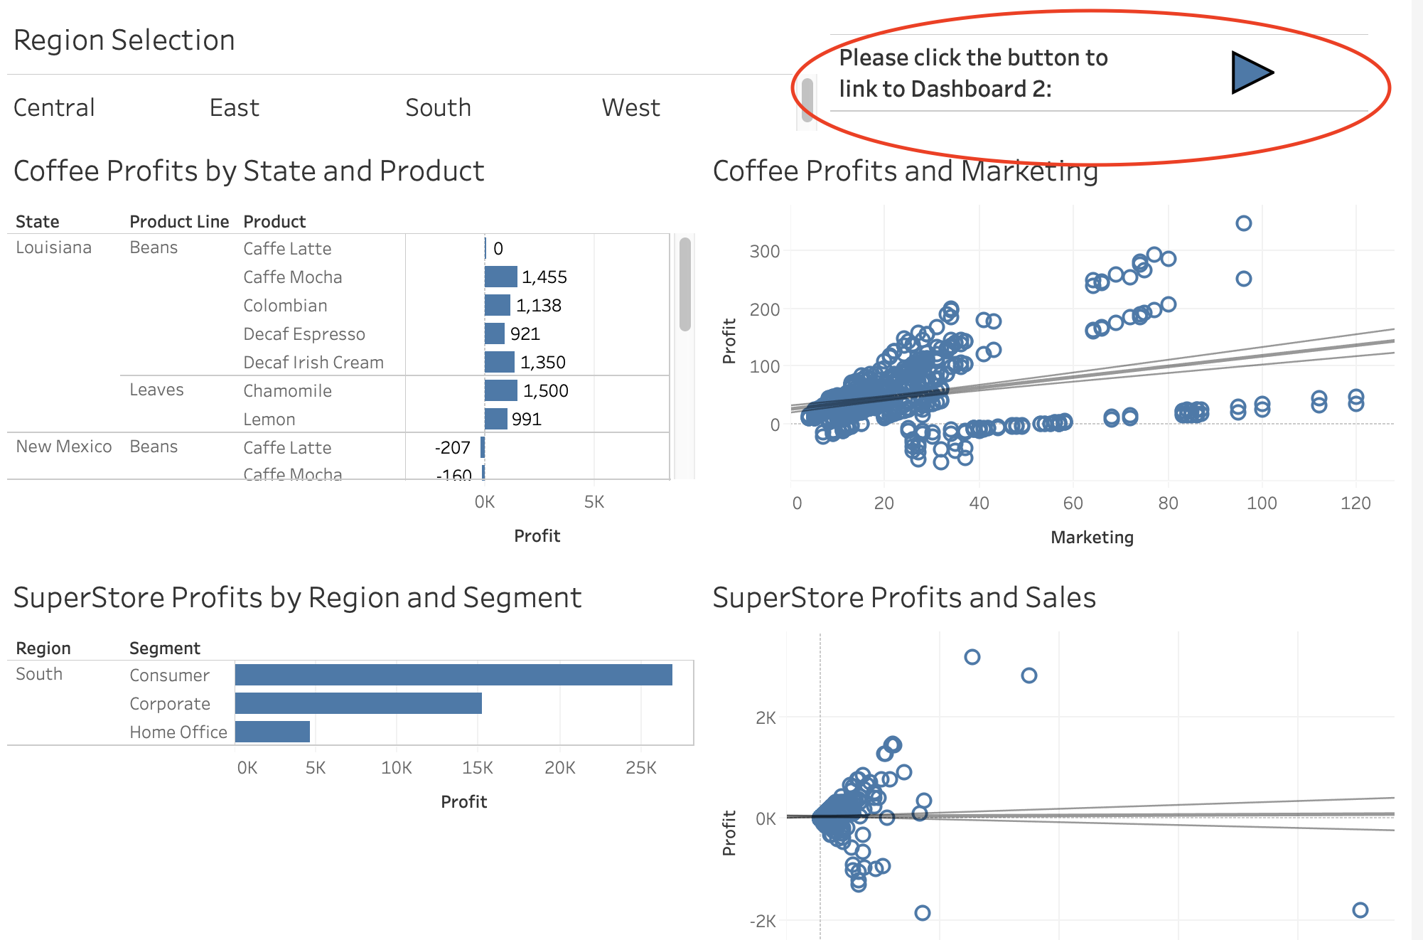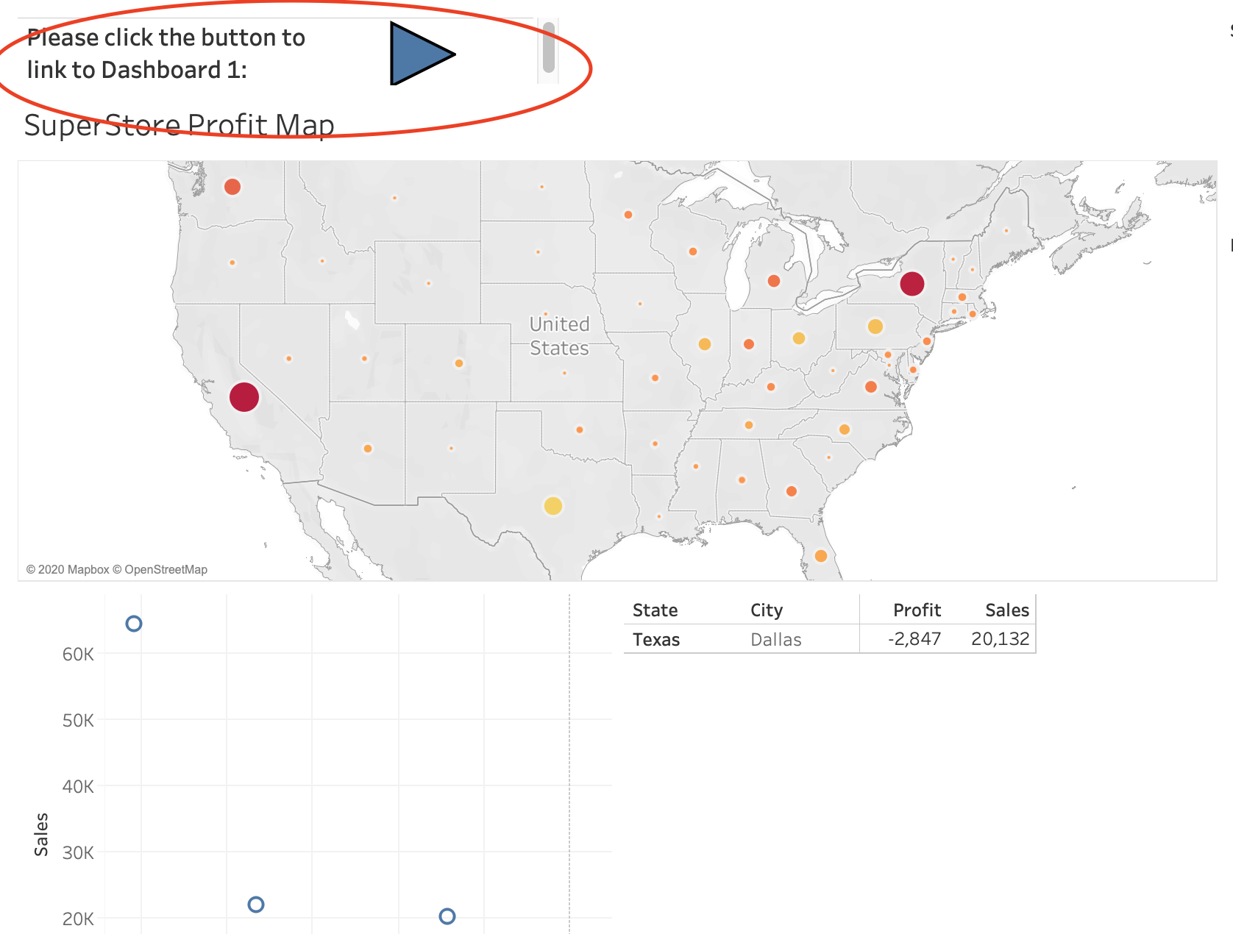

2. Add context to filter

**Please use “Assignment 3 Q2.twbx” to complete the following tasks:**

a. Generate a dashboard with worksheets “Top 10 Areas”, “Profit in Region” and “Top 5 Products”;

b. Filter top 10 areas and top 5 products with highest sum of profits in “Top 10 Cities” and “Top 5 Products” worksheets;

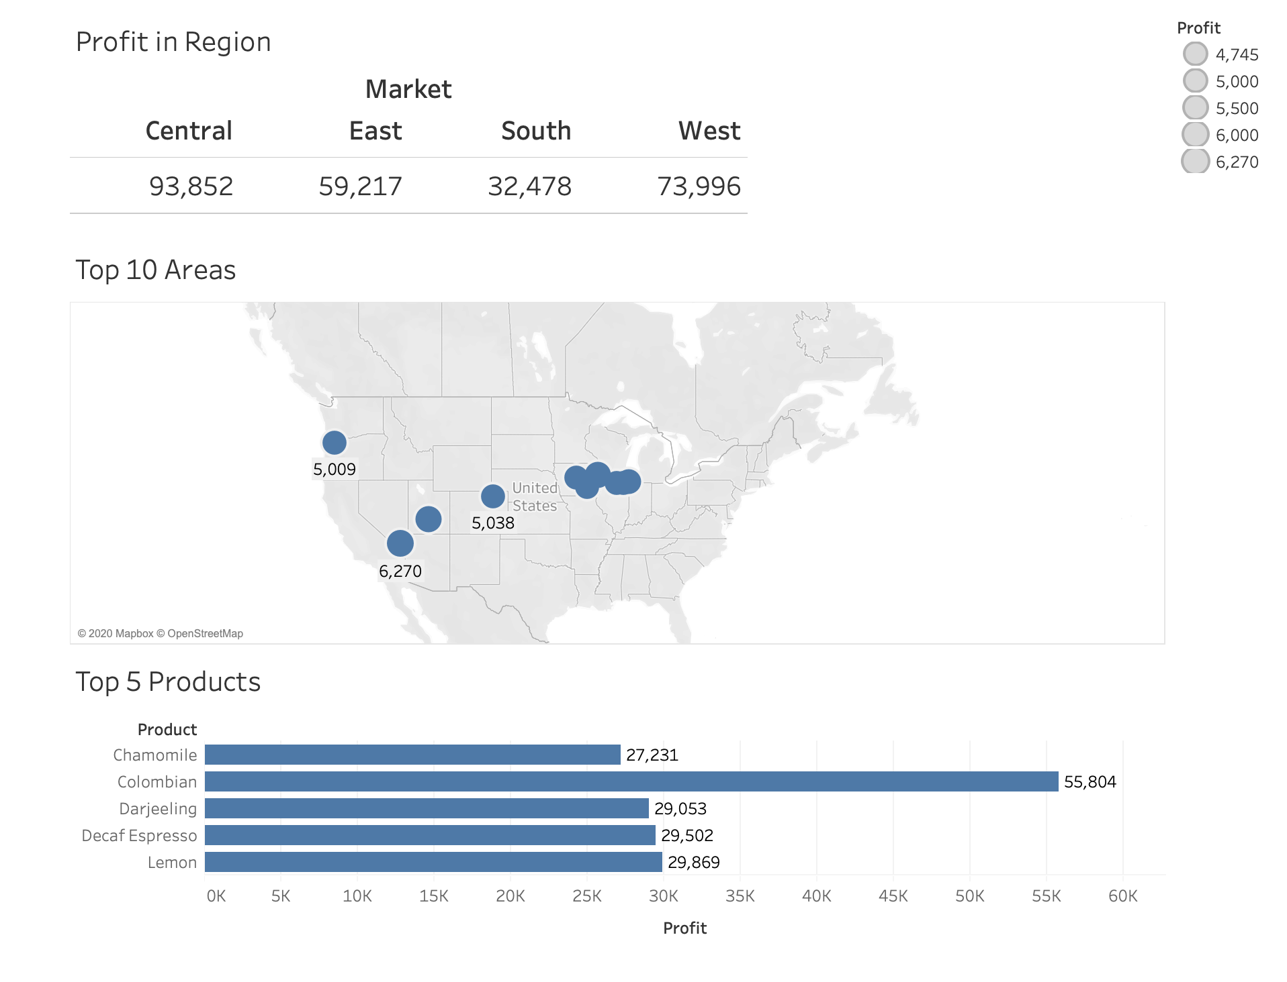

c. Use Market levels (e.g. Central) to filter the content in “Top 10 Areas”, and use the areas from “Top 10 Areas” to filter the products in “Top 5 Products”;

d. Add context to the filters, so when you select Market levels (e.g. Central), top 10 areas from that level will be displayed; when you select one area from the map, top 5 products from that area will be shown.

